**Hunter and Pigeons**

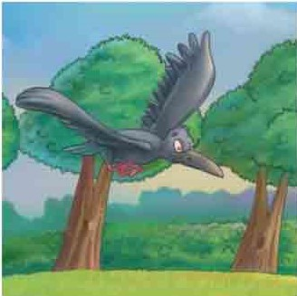

While he was flying and enjoy with the beautiful nature in the forest, he saw a hunter is doing set up his trap to catch the animal.

Once upon a time, in the beautiful day, there was a full of black crow is flying in the forest. It is very good because he can see everything in the forest.

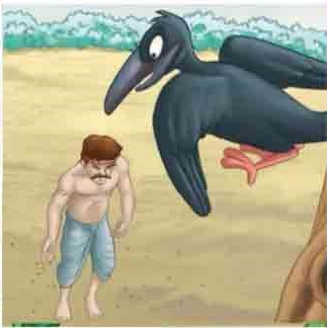

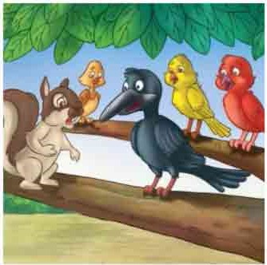

So they decide flying to the forest. When they arriving in the forest, they saw a lot of rice on the ground. One of them say “Now we know why the crow are lying. It is the reason”. Then they went down to eat all the rice on the ground.

The crow took this information to tell all the animals in the forest. When all the animals heard about this information, they feel very scared. But the pigeons they don’t believe what the crow say, they think the crow are doing lying to them.

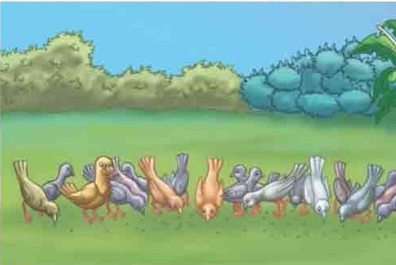

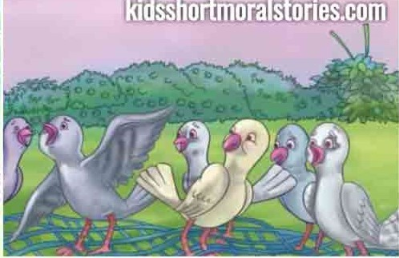

At that time, one of them are say an idea “ If we want to get of this net, we must unite and try to flying together at the same time. They started doing it, then they can flying and get of there with that net with them.

While they was eating the rice. There was a net are fell down on them. They feel very scared of what happened on them. But they never give up. They try to get out of that net, but they can’t do it.

